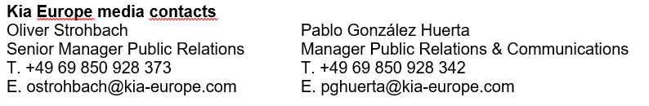
NEWS
For immediate release

Kia achieves highest-ever
European market share

- Record-breaking performance in Europe was realised in 2021, with market share jumping up from 3.5% to 4.3%
- In total, 502,677 units were sold in Europe in 2021, up by 20.6% from the previous year
- Kia continues outstanding growth against a struggling passenger car market that has declined by 1.5%
- Last year’s impressive results included a growing share for sales of Kia's electrified vehicles, which reached a high of 45% in Q3
January 18, 2022 – Kia has achieved its highest-ever European market share against a backdrop that saw the overall new passenger car market decline. According to new data released today by the European Automobile Manufacturers’ Association (ACEA), Kia’s European market share in 2021 hit a high of 4.3%, increasing from 3.5% in 2020.

Kia’s total annual sales across EU, EFTA and UK markets also grew during 2021, with the brand selling 502,677 units, a rise of 20.6% compared to the 416,715 units Kia sold during 2020. These successful figures are in stark contrast to the overall new passenger car market which saw a decline of 1.5%; largely the result of tough market conditions caused by the Covid-19 pandemic and the global semiconductor chip shortage.

Kia overcame the production difficulties experienced by many other car makers by quickly sourcing parts and adapting production at the company’s advanced manufacturing hub in Slovakia in order to meet demand. As a result, the 2021 sales figures were just 168 units short of the 502,845 units the brand sold in 2019, the year before the onset of the Covid-19 pandemic and the resulting chip shortage.

Kia’s 2021 brand relaunch included the aim to become a leading sustainable mobility solutions provider with a growing line-up of eco-friendly electrified vehicles. Last year’s impressive results included a growing share for sales of Kia's electrified vehicles, which reached a high of 45% in Q3.

Jason Jeong, President of Kia Europe, commented, “2021 has been a hugely successful year for Kia in Europe, with our best-ever market share testament to the hard work of my colleagues both at Kia and across our dealership network. Our award-winning, state-of-the-art vehicles continue to win the hearts of European customers, thanks to their winning combination of design, performance and technology.”

“While successful, last year was also a momentous year for Kia in which we reinvented the brand and ushered in a bold new design philosophy called ‘Opposites United’. Whether it’s the launch of our first dedicated battery electric vehicle (BEV), the EV6, our all-new European-designed and electrified Kia Sportage SUV, or the reveal of our all-new eco-friendly Niro CUV, these exciting products demonstrate Kia’s growing leadership in this era of electrification.”

Kia aims to establish a fully electrified line-up in Europe by 2035, with a total of 11 BEVs joining the range by 2026. Seven of these BEVs, the first of which was the EV6, will be based on Kia’s dedicated Electric Global Modular Platform (E-GMP).

# # #
About Kia Europe
Kia Europe is the European sales, marketing and service arm of Kia Corporation. With its headquarters in Frankfurt, Germany, it covers 39 markets across Europe and the Caucasus.

