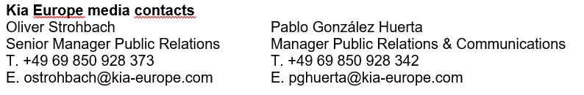
NEWS
For immediate release

Kia achieves a 4.9% market
share in February

- Results record a strong start to 2022 for the Korean brand, with an overall market share of 5.3%
- Kia sales reach 39,149 units in February, up 24.8% over the same period last year
- Robust performance from Kia is in stark contrast to how the new car market is performing, having dropped by 6.7%
- Results follow 2022 European Car of the Year accolade for EV6
March 18, 2022 – Kia has achieved a 4.9% market share across Europe in February, up 1.2% over the same period last year according to new data released today by the European Automobile Manufacturers’ Association (ACEA). The results have also highlighted a strong start to the year, in which Kia’s market share grew by 1.4% to reach an impressive 5.3% for the first two months of the year.

Kia’s registrations across EU, EFTA and UK markets reached 39,149 units last month, a rise of 24.8% compared to the same period last year. Kia has so far sold a total of 86,286 vehicles in 2022, an increase of 32%, highlighting Kia’s continued success in the European region.

Kia’s performance compares favourably to the overall new passenger car market which dropped by 6.7%, the weakest February in terms of sales volumes since ACEA records began. While many carmakers are continuing to face supply chain difficulties caused by semiconductor shortages, Kia has continued to work with its suppliers to avoid production delays.

Jason Jeong, President of Kia Europe, commented: “February marks another impressive month as we continue to see year-on-year market share and sales increases. As fuel prices continue to soar, more buyers than ever are being drawn to our line-up of award-winning electrified vehicles. With the EV6 being crowned 2022 European Car of the Year and an all-new Niro set to arrive in the next few months, I look forward to this outstanding positive trajectory continuing.”
# # #
About Kia Europe
Kia Europe is the European sales, marketing and service arm of Kia Corporation. With its headquarters in Frankfurt, Germany, it covers 39 markets across Europe and the Caucasus.

